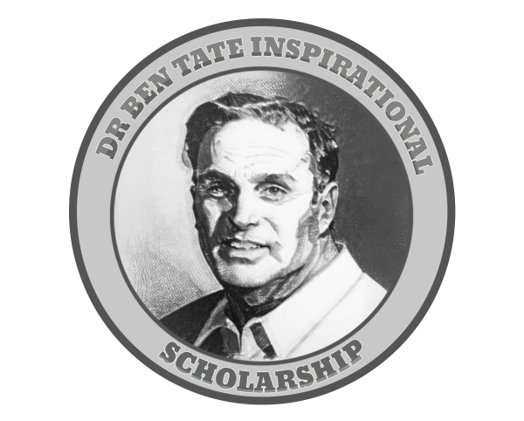

The Dr. Ben Tate Inspirational Scholarship

About the scholarship: Each year The Dr. Ben Tate Inspirational Scholarship Fund awards a $1,000 scholarship to an aspiring young writer/artist. The scholarship was established by one of Dr. Tate's pupils and administered by the Comics Appreciation Project Inc. (CAP). CAP a 501c3 nonprofit created to support youth literacy and promote the literary value of visual storytelling.

Eligibility: Currently, any student enrolled in high school (9th - 12th grade) in the states of Georgia and North Carolina are eligible to apply. AI-Assisted work is not permitted at this time. Applications are due by April 1st. Winners will be announced by May 1st.

Disbursements: The scholarship will be disbursed directly to the student’s account at the college, university, or technical school that they matriculate to after high school graduation.

Requirements: Applicants must submit each of the following for consideration:

- Completed Application Form
- A short essay (500 words) expressing your interest in comics/graphic novels
- A comic-style art sample should consist of 3-6 pieces of scanned original work that displays your current style and interest.
- Writing Sample - A corresponding script for your art sample (approximately 2-5 pages).

Applicant’s Full Name:
Home Address:
Telephone:
Email:
Applicant’s High School (Name, City, and State)

Your samples must have been verified by a current sponsoring high school teacher/staff (with their contact information provided to us below). Your sponsoring teacher must have already seen the submitted samples of your work and be able to attest to their authenticity.

Sponsoring Teacher’s Name:
Sponsoring Teacher’s Work Email:
Sponsoring Teacher’s Work Phone Number:
Sponsoring Teacher’s School:

For more information, please contact us at the following:

Comics Appreciation Project
Attn: Jason Kelley
Ref: The Dr. Ben Tate Inspirational Scholarship Fund
comicsappreciationproject@gmail.com
706-395-5030

Scholarship Application Grading Rubric (Possible 100 Points)

1. Required: Short Essay (30 points)
- Interest and Passion (20 points)
  - 20 points: Clearly demonstrates a deep passion and interest in comics/graphic novels, with thoughtful insights or personal anecdotes.
  - 10 points: Some expression of interest, but lacks depth or specificity.
  - 0 points: Little to no evidence of interest in comics/graphic novels.
- Clarity and Writing Quality (10 points)
  - 10 points: Well-written, grammatically sound, and easy to read. Ideas are coherent and engaging.
  - 5 points: Generally clear but contains some grammatical errors or lacks flow.
  - 0 points: Poorly written, difficult to follow, or contains numerous errors.

2. Required: Comic Art Sample Sample (30 points)
- Creativity (10 points)
  - 10 points: Work demonstrates exceptional creativity and originality. Ideas are compelling.
  - 5 points: Some creativity, but work relies on familiar tropes or lacks originality.
  - 0 points: Little to no evidence of creativity or originality.
- Technical Skill (10 points)
  - 10 points: Strong technical skills appropriate for the applicant's age and experience. Demonstrates command of medium (art).
  - 5 points: Moderate technical skill with room for improvement.
  - 0 points: Lacks technical skill, with significant deficiencies in execution.
- Presentation and Completeness (10 points)
  - 10 points: Fully meets submission requirements (e.g., 3-6 pieces of art). Work is polished and professional in presentation.
  - 5 points: Mostly meets requirements but with minor issues in presentation or format.
  - 0 points: Submission does not meet requirements or is poorly presented.

3. Required: Comic Script Sample (30 points)
- Storytelling & Narrative Development (10 points)
  - 10 points: Script presents a clear, engaging story with purposeful pacing, meaningful character actions, and a strong sense of beginning, middle, and end (or a compelling excerpt from a larger narrative)
  - 5 points: Story ideas are present, but narrative structure, pacing, or clarity is underdeveloped.
0 points: Narrative is unclear, incomplete, or difficult to follow.
- Understanding of the Comics Form (10 points)
  - 10 points: Demonstrates strong understanding of comics scripting, including effective use of panels, dialogue, captions, and visual direction. Writing clearly supports visual storytelling.
  - 5 points: Shows basic understanding of comics scripting, but panel descriptions, dialogue, or pacing may be inconsistent or unclear.
  - 0 points: Little evidence of understanding how scripts translate into comic pages/panels.
- Presentation and Completeness (10 points)
  - 10 points: Fully meets submission requirements (e.g., 3-6 pieces of art). Work is polished and professional in presentation.
  - 5 points: Mostly meets requirements but with minor issues in presentation or format.
  - 0 points: Submission does not meet requirements or is poorly presented.

4. Optional: Sponsoring Teacher Letter of Recommendation (10 points)
- 10 points: Submits a glowing letter of recommendation from a teacher/librarian/counselor that can speak to the applicant’s passion and can attest to the integrity of their submitted work.
- 5 points: Submits a letter attesting to the integrity of the submitted work.
- 0 points: No letter submitted.

