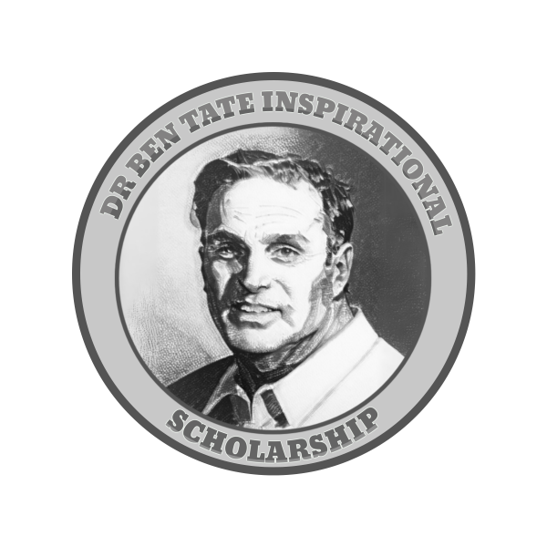

**The Dr. Ben Tate Inspirational Scholarship**

**About the scholarship:** Each year The Dr. Ben Tate Inspirational Scholarship Fund awards a $1,000 scholarship to an aspiring young writer or artist. The scholarship was established by one of Dr. Tate's pupils and administered by the Comics Appreciation Project Inc. (CAP). CAP a 501c3 nonprofit created to support youth literacy and promote the literary value of visual storytelling.

**Eligibility:** Currently, any student enrolled in high school (9th - 12th grade) in the state of Georgia (US) is eligible to apply. **Applications are due by April 1st**. Winners will be announced within 30 days.

**Disbursements:** The scholarship will be disbursed directly to the student’s account at the college, university, or technical school that they matriculate to after high school graduation.

**Requirements:** Applicants must submit each of the following for consideration:

1. Completed Application Form
2. A short essay (500 words) expressing your interest in comics/graphic novels
3. Either an art and/or writing sample. Art samples should consist of 3-6 pieces of scanned original work that displays your current style and interest. Writing samples should be in the form of a script and be 2-5 pages. Special attention will be given to applicants that submit copies of both original comic art pages with their original script. *AI-Assisted work is not permitted
4. Your samples must be verified by a current sponsoring high school teacher/staff (with their contact information provided below)

Applicant’s Full Name:

|  |
| --- |

Home Address:

|  |
| --- |

Telephone:

|  |
| --- |

Email:

|  |
| --- |

Applicant’s High School (Name, City, and State)

|  |
| --- |

Your sponsoring teacher must have already seen the submitted samples of your work and be able to attest to their authenticity.

Sponsoring Teacher’s Name:

|  |
| --- |

Sponsoring Teacher’s Work Email:

|  |
| --- |

Sponsoring Teacher’s Work Phone Number:

|  |
| --- |

Sponsoring Teacher’s School:

|  |
| --- |

For more information, please contact us at the following:

[bentatescholarship@gmail.com](mailto:bentatescholarship@gmail.com)

### **Scholarship Application Grading Rubric (Possible 100 Points)**

### **1. Required: Short Essay (30 points)**

* **Interest and Passion (20 points)**
  + **20 points**: Clearly demonstrates a deep passion and interest in comics/graphic novels, with thoughtful insights or personal anecdotes.
  + **10 points**: Some expression of interest, but lacks depth or specificity.
  + **0 points**: Little to no evidence of interest in comics/graphic novels.
* **Clarity and Writing Quality (10 points)**
  + **10 points**: Well-written, grammatically sound, and easy to read. Ideas are coherent and engaging.
  + **5 points**: Generally clear but contains some grammatical errors or lacks flow.
  + **0 points**: Poorly written, difficult to follow, or contains numerous errors.

### **2. Required: Art and/or Writing Sample (50 points)**

* **Creativity and Originality (20 points)**
  + **20 points**: Work demonstrates exceptional creativity and originality. Ideas are compelling and distinct.
  + **10 points**: Some creativity, but work relies on familiar tropes or lacks originality.
  + **0 points**: Little to no evidence of creativity or originality.
* **Technical Skill (20 points)**
  + **20 points**: Strong technical skills appropriate for the applicant's age and experience. Demonstrates command of medium (art or writing).
  + **10 points**: Moderate technical skill with room for improvement.
  + **0 points**: Lacks technical skill, with significant deficiencies in execution.
* **Presentation and Completeness (10 points)**
  + **10 points**: Fully meets submission requirements (e.g., 3-6 pieces of art or 2-5 pages of script). Work is polished and professional in presentation.
  + **5 points**: Mostly meets requirements but with minor issues in presentation or format.
  + **0 points**: Submission does not meet requirements or is poorly presented.

### **3. Optional: Combined Comic Art w/ Script Submission (10 points)**

* **10 points**: Submits both an original comic script and corresponding art pages. The applicant demonstrates a strong grasp of the cartoonist’s ability to both write and render a story.
* **5 points**: Submits both but lacks clear cohesion between the script and art.
* **0 points**: Does not submit both components.

### **4. Optional: Sponsoring Teacher Letter of Recommendation (10 points)**

* **10 points**: Submits a glowing letter of recommendation from a teacher/librarian/counselor that can speak to the applicant’s passion and can attest to the integrity of their submitted work.
* **5 points**: Submits a letter attesting to the integrity of the submitted work.
* **0 points**: No letter submitted.